Experiment No: 08
Experiment Name: Traversing, Searching, Insertion and Deletion in a Doubly Linked List and Circular Linked List
Objectives:
- To implement Doubly Linked List and Circular Linked List and perform operations such as traversal, searching, insertion and deletion
- To understand dynamic memory management, pointer manipulation and optimized data structures for efficient data handling
Theory:
A Doubly Linked List is a linear dynamic data structure where each node contains data, a pointer to the next node and a pointer to the previous node. Traversal can be performed in both forward and backward directions
A Circular Linked List is a variation where the last node points back to the head, allowing circular traversal. These structures allow dynamic insertion and deletion at any position efficiently compared to static arrays
Algorithms:
1.1 | Traversal (Doubly Linked List):
- Start from head
- Move forward using next pointer and display each node
- Move backward from last node using prev pointer
1.2 | Traversal (Circular Linked List):
- Start from head
- Move forward using next until reaching head again
2 | Searching:
- Start from head
- Compare each node’s data with the target
- If found, display the position; otherwise, continue
3 | Insertion:
- Beginning: Update head and node pointers
- End: Traverse to last node, update pointers
- Specific Position: Traverse and adjust pointers to insert
4 | Deletion:
- Beginning: Update head, adjust pointers, free node
- End: Traverse to last node, update previous node’s pointer, free node
- Specific Position: Traverse, update adjacent nodes, free node
Code:
Doubly Linked List:
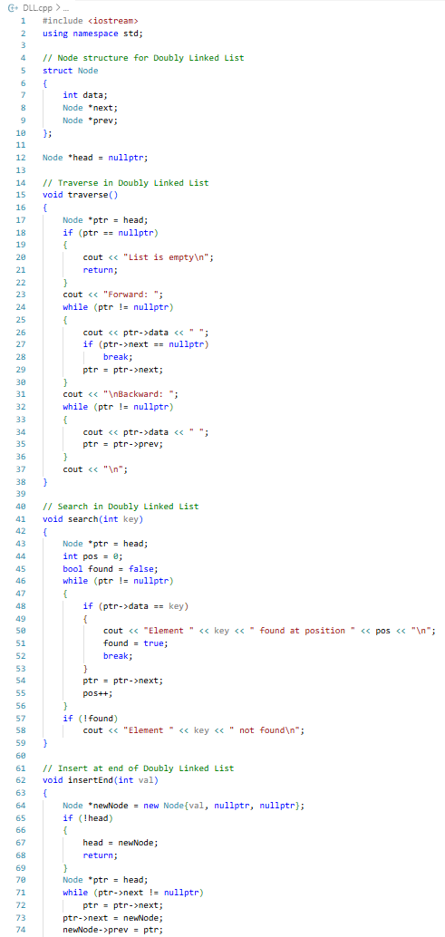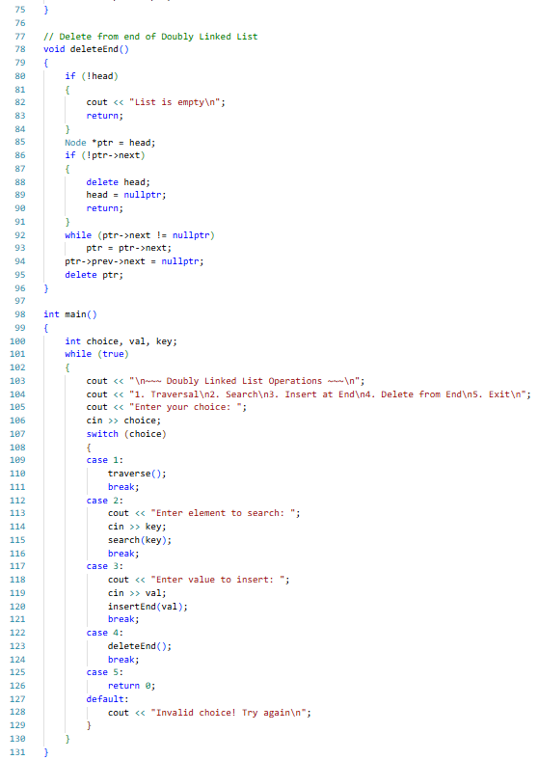

Circular Linked List:
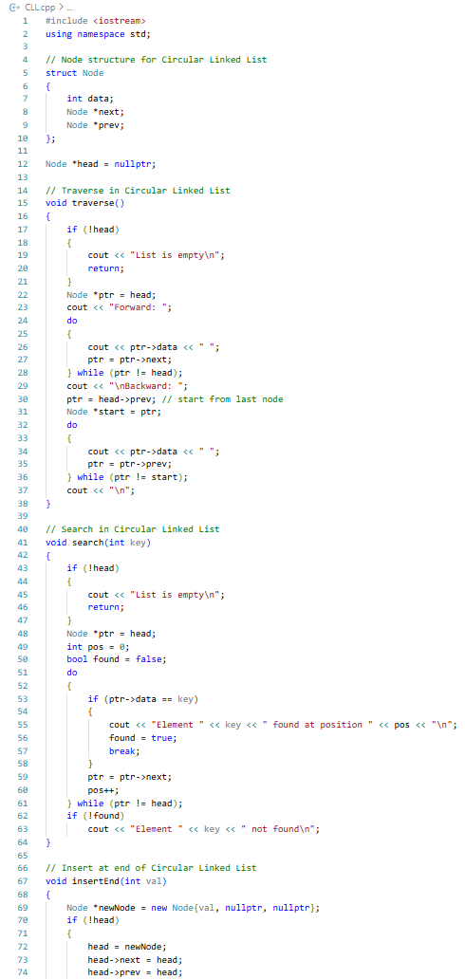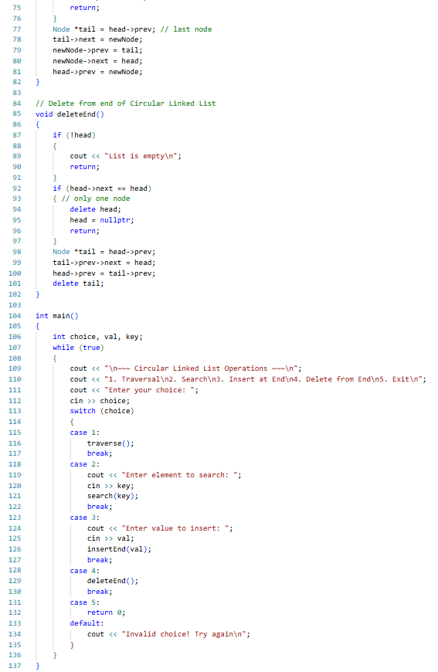
Procedure:
- VS Code was opened and a new project was created
- The Doubly Linked List code was written, compiled and syntax errors fixed
- Menu driven operations such as Traversal, Search, Insert, Delete were performed and changes were verified after each action
- Forward and backward traversal was observed to ensure correctness and memory was freed when nodes were deleted
- The Doubly Linked List code was extended to the Circular Linked List by linking the last node to head and updating head->prev
- The Circular Linked List operations were tested, ensuring traversal, insertion and deletion maintained proper circular links
Results:
Doubly Linked List:
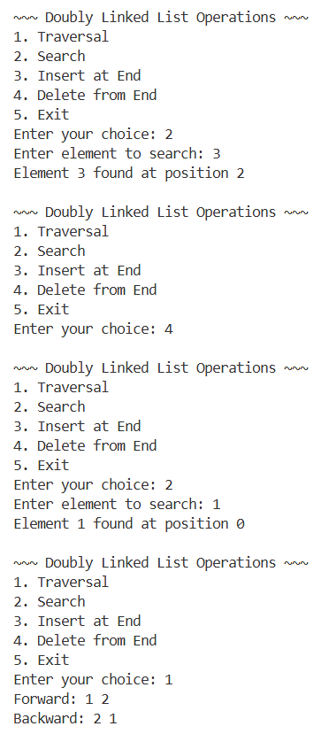
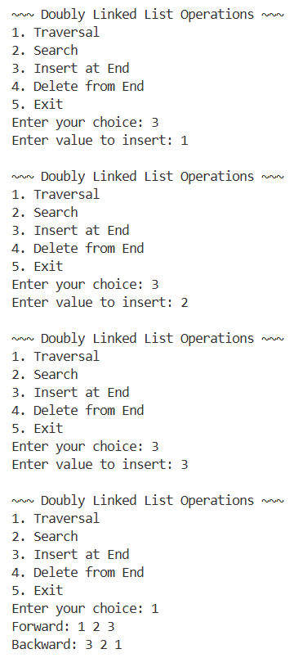
Circular Linked List:
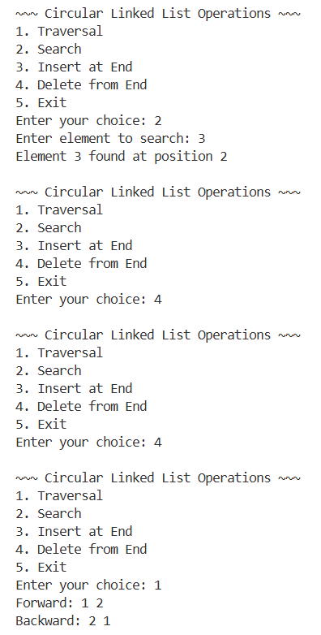
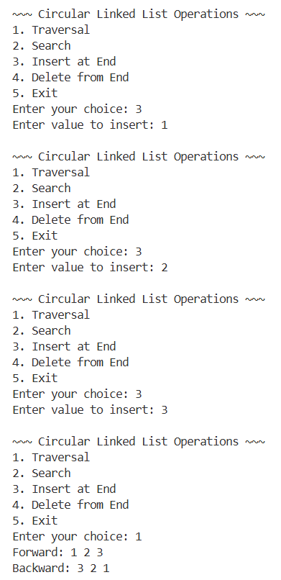
Complexity Analysis:
Operation | Time Complexity | Space Complexity
Traversal (DLL/CLL) | O(n) | O(1)
Searching | O(n) | O(1)
Insertion at beginning | O(1) | O(1) per node
Insertion at end | O(n) | O(1) per node
Deletion at beginning | O(1) | O(1)
Deletion at end | O(n) | O(1)
Precautions:
- Always checked for NULL pointers before accessing nodes
- Validated positions for insertion and deletion to avoid segmentation faults
- Freed memory of deleted nodes to prevent memory leaks
- Avoided negative or invalid indices during operations

Limitations:
- Random access is inefficient compared to arrays
- Operations require pointer manipulation, which may lead to errors if not careful
Conclusion:
This experiment provided hands on experience in implementing and manipulating Doubly Linked Lists and understanding the logic for Circular Linked Lists. By completing this lab, we gain a solid understanding of advanced pointer based dynamic data structures, foundational for stacks, queues and complex structures like graphs

Experiment No: 09
Experiment Name: Traversing Binary Tree, Binary Search Tree, Insertion and Deletion on Binary Search Tree
Objectives:
- To implement Binary Tree traversal techniques (Inorder, Preorder and Postorder)
- To implement Binary Search Tree operations such as insertion and deletion
Theory:
A Binary Tree (BT) is a hierarchical data structure where each node has at most two children: left and right. It does not enforce any ordering on values

Tree traversal techniques are used to visit all nodes:
- Inorder (Left → Root → Right)
- Preorder (Root → Left → Right)
- Postorder (Left → Right → Root)

On the other hand, a Binary Search Tree (BST) is a special type of binary tree where:
- Left subtree contains smaller values than root
- Right subtree contains larger values than root
Algorithms:
1. Binary Tree Traversal:
1.1 | Inorder (Left → Parent → Right)
1.2 | Preorder (Parent → Left → Right)
1.3 | Postorder (Left → Right → Parent)
2. Binary Search Tree:
2.1 | Insertion:
  - Start from root
  - If tree is empty, create root node
  - Compare value:
    - If smaller → go left
    - If larger → go right
  - Insert at correct position
2.1 | Deletion:
  - Search for node
    - Case 1: No child → delete directly
    - Case 2: One child → replace with child
    - Case 3: Two children → replace with inorder successor
Code:
1. Binary Tree Traversal
1.1 | Inorder
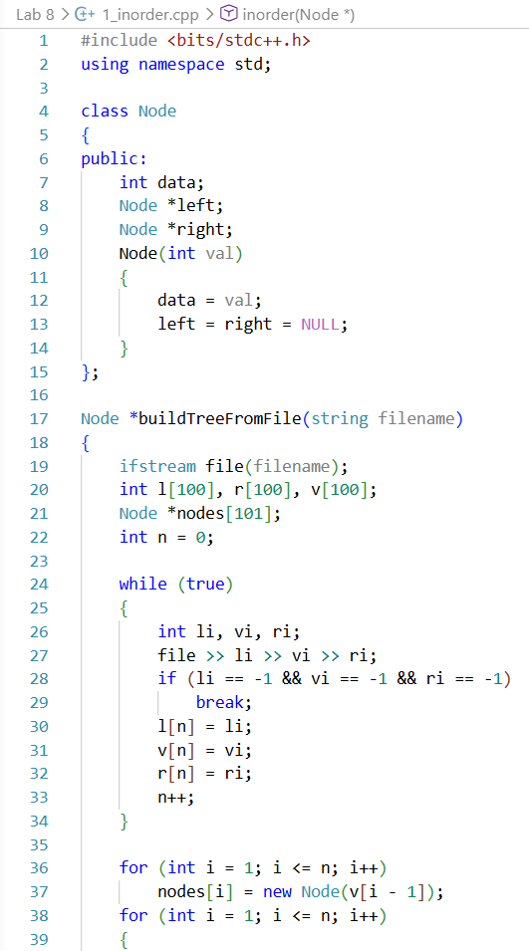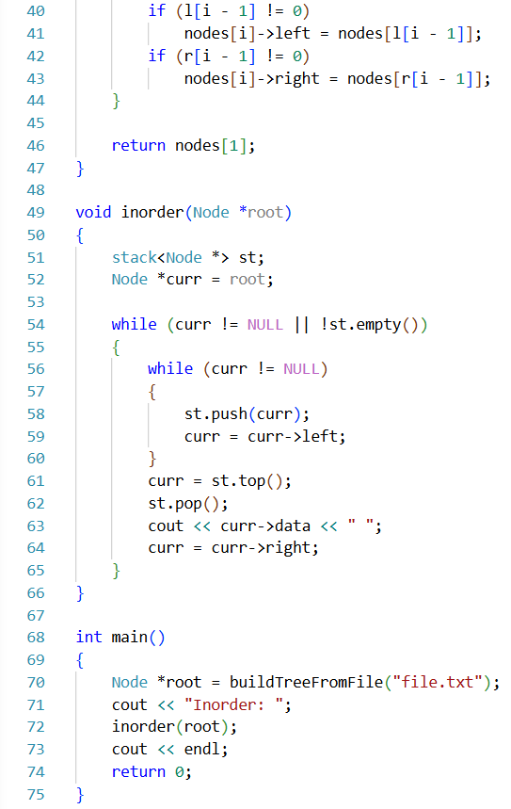

1.2 | Preorder
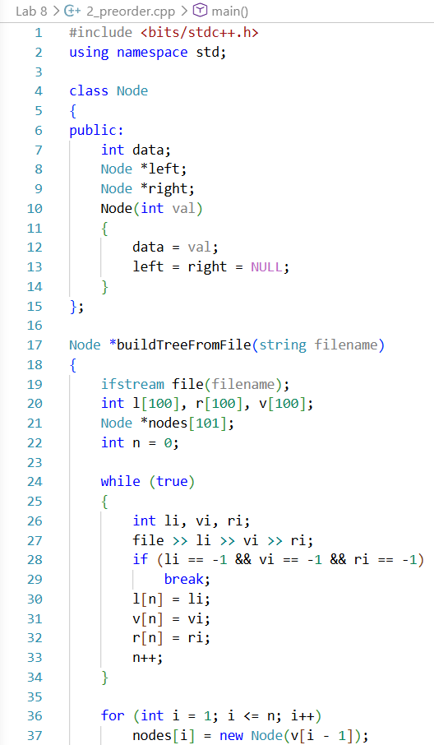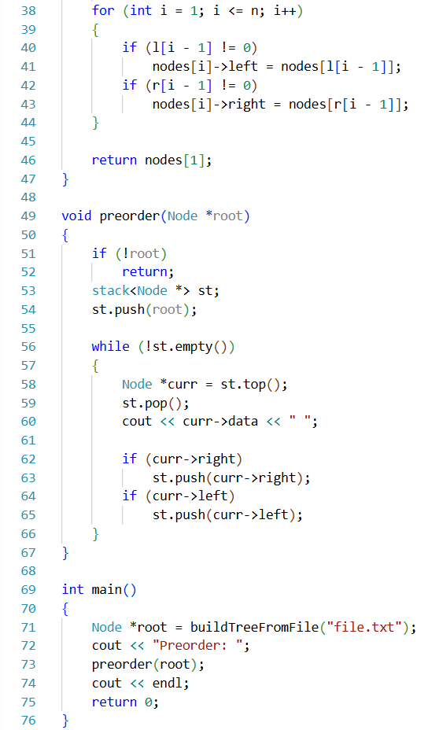

1.3 | Postorder
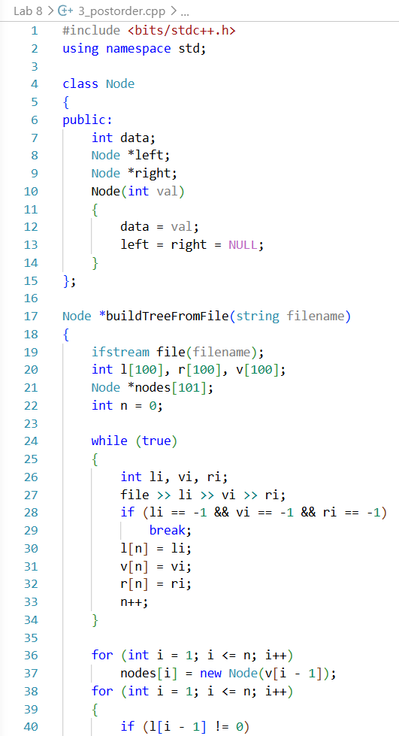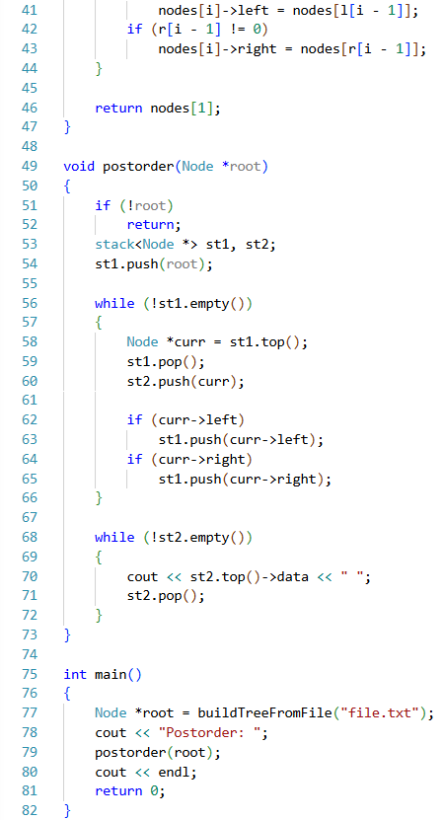

Input File (file.txt):
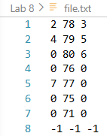
2. Binary Search Tree
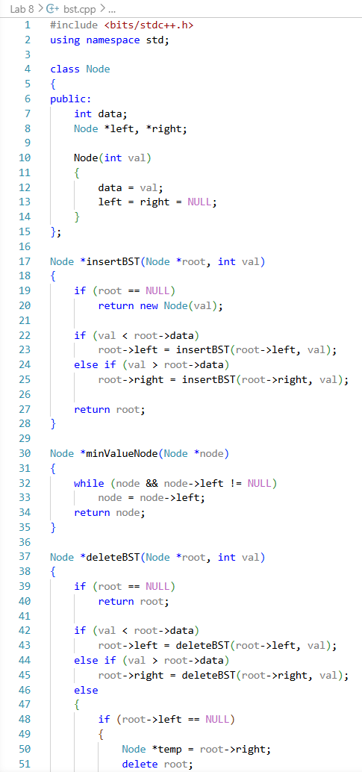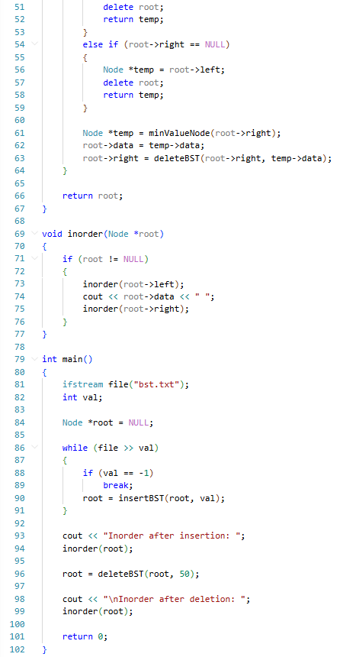

Input File (bst.txt):
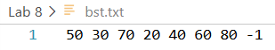
Procedure:
- IDE (VS Code) was opened and project created
- Binary Tree traversal programs were executed using file input
- Outputs of Inorder, Preorder, Postorder were verified
- BST program was compiled and executed using separate file input
- Insertion and deletion operations were tested
- Outputs were verified using inorder traversal
Results:
Binary Tree:
Binary Search Tree:
Complexity Analysis:
Operation | Time Complexity | Space Complexity
Tree Traversal | O(n) | O(1)
BST Insertion | O(h) | O(1)
BST Deletion | O(h) | O(1)

Here, h = height of tree
Precautions:
- Ensured correct file format before execution
- Checked NULL pointers before operations
- Avoided invalid node access during deletion
- Verified output after each operation
Limitations:
- BST may degrade to O(n) in worst case
- File-based structure requires careful formatting
- No direct random access like arrays
Conclusion:
This experiment successfully demonstrated Binary Tree traversal and Binary Search Tree operations. Binary Tree traversal helped understand hierarchical structure navigation, while BST operations provided insight into efficient data organization using ordered insertion and deletion. These concepts are fundamental for advanced data structures and algorithms

